SECURE HEALTH GENERAL HOSPITAL
HOSPITAL PERFORMANCE DASHBOARD
Excel Data Analytics Project | 2024–2025
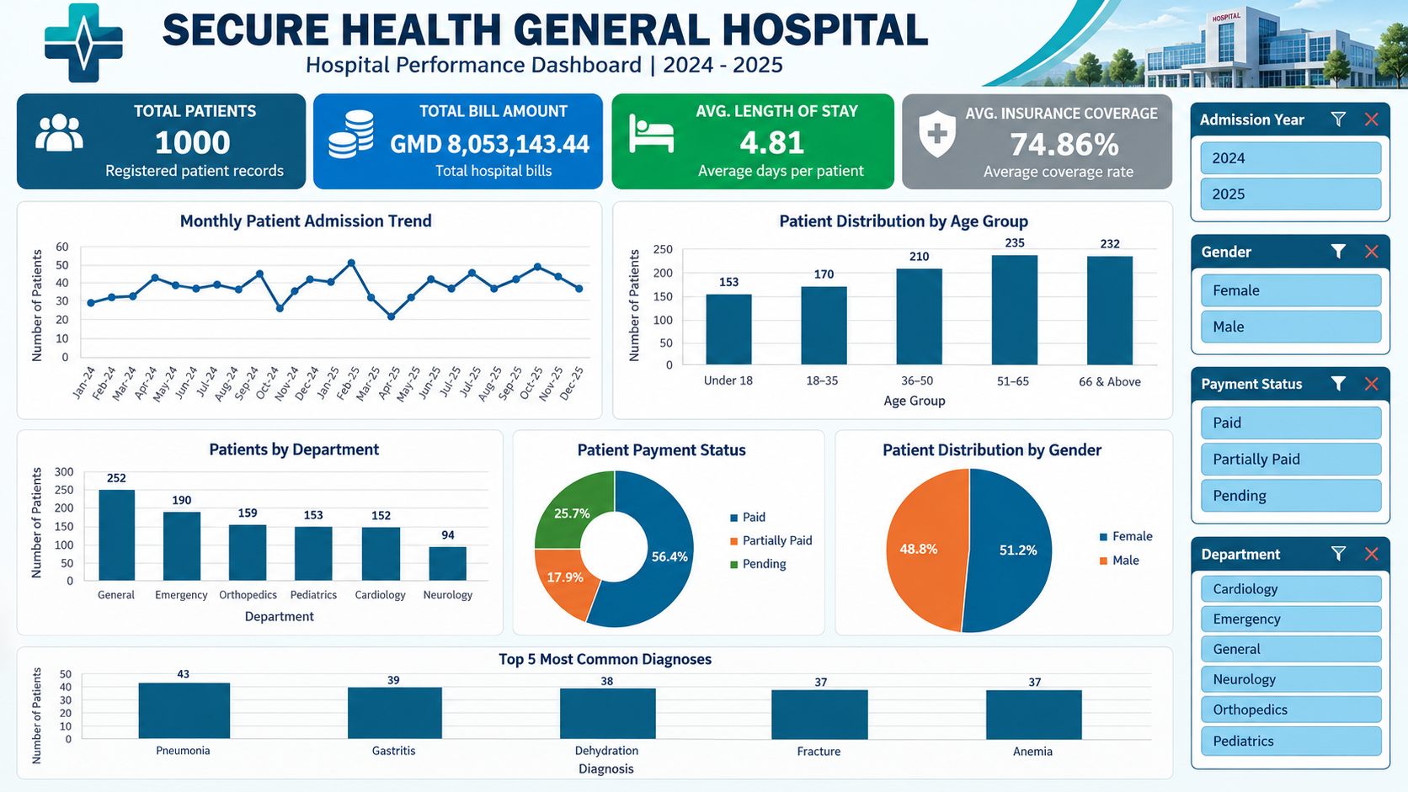
Prepared as an academic data analytics assignment

1. Introduction
This project analyses the Secure Health General Hospital patient dataset and presents the findings in an interactive Microsoft Excel dashboard. The dashboard is designed to give hospital management a concise view of patient admissions, demographic distribution, department workload, payment status, insurance coverage and commonly recorded diagnoses.
The workbook uses an Excel Table, calculated KPI values, PivotTables, PivotCharts and slicers. Users can filter the analysis by admission year, gender, payment status and department.

2. About the Dataset
The supplied hospital dataset contains 1,000 patient records covering the 2024–2025 period. The data includes patient identifiers and fields used for analysis such as age group, gender, admission date/month, department, diagnosis, length of stay, bill amount, payment status and insurance coverage.
The dataset was converted into an Excel Table named HospitalData to support structured references and more reliable PivotTable analysis. The figures in this report reflect the prepared workbook and the dashboard values verified during development.

3. Problem Statement
Hospital management needs a clear and accessible way to understand patient activity and selected operational and financial indicators. Reviewing individual records alone makes it difficult to identify admission patterns, compare patient volumes across age groups and departments, monitor payment categories, and summarise the most frequently recorded diagnoses.
This project addresses that reporting need by consolidating the supplied records into an interactive Excel dashboard. This is the project framing based on the assignment brief; the lecturer's original Data Dictionary & Problem Statement document should be treated as the authoritative wording if it differs.

4. Tools and Methodology
- Microsoft Excel was used for data preparation, calculations, analysis and dashboard design.
- The source records were formatted as an Excel Table named HospitalData.
- KPI calculations summarised patient count, total bill amount, paid bill value, average length of stay and average insurance coverage.
- PivotTables summarised admissions by month, patients by age group, department, payment status, gender and diagnosis.
- PivotCharts visualised the six analysis areas.
- Slicers were added for admission year, gender, payment status and department, and connected to the six PivotTables.

5. Key Performance Indicators
KPI | Result
Total patients | 1,000
Total bill amount | GMD 8,053,143.44
Fully paid bill value | GMD 4,568,527.32
Average length of stay | 4.81 days
Average insurance coverage | 74.86%
Fully paid patients | 564
Partially paid patients | 179
Pending patients | 257

6. Insights and Findings
- Patient volume: The dataset contains 1,000 patient records across 2024 and 2025.
- Age distribution: The 51–65 group is the largest with 235 patients (23.5%), followed by the 66 & Above group with 232 (23.2%). The Under 18 group has 153 patients (15.3%).
- Department workload: General has the highest patient count (252), followed by Emergency (190), Orthopedics (159), Pediatrics (153), Cardiology (152) and Neurology (94).
- Payment status: 564 patients (56.4%) are marked Paid, 179 (17.9%) Partially Paid and 257 (25.7%) Pending. Therefore, 43.6% of records are not marked fully paid.
- Gender distribution: 512 patients (51.2%) are Female and 488 (48.8%) are Male, a relatively balanced distribution.
- Most common diagnoses: The dashboard's Top 5 view shows Pneumonia (43), Gastritis (39), Dehydration (38), Fracture (37) and Anemia (37).
- Admission trend: Monthly admission counts vary across the 24 months shown. The line chart makes month-to-month fluctuations visible for review.

7. Dashboard Visualization
The screenshot below shows the Excel dashboard after the main corrections and full-data view were restored. The workbook itself contains the interactive slicers and PivotCharts.
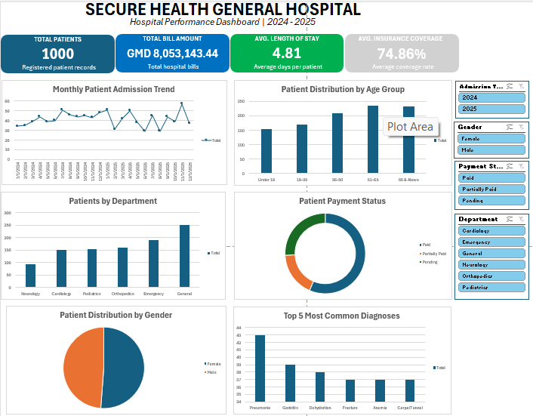

8. Recommendations
- Review the 257 records marked Pending and the 179 marked Partially Paid, and establish a consistent billing follow-up process.
- Review staffing, capacity and workload distribution in the General and Emergency departments, which have the highest patient volumes.
- Use the monthly admission trend to support staffing and resource planning, while investigating unusually high or low months.
- Continue monitoring age-group and gender distributions to support service planning; do not assume these descriptive counts alone explain clinical need.
- Review the diagnosis categories with clinical teams before making service or procurement decisions. Diagnosis frequency alone does not measure severity, outcomes or quality of care.
- Maintain data quality by checking date fields, missing values, duplicate patient identifiers and consistent category labels during future updates.

9. Limitations and Interpretation
This is a descriptive analysis of the supplied dataset. It identifies counts, distributions and recorded financial/payment categories; it does not establish causes, clinical outcomes, departmental efficiency or quality of care. The average insurance coverage KPI is reported as calculated in the workbook. The Top 5 diagnosis chart is a filtered view and should not be interpreted as a count of all patient records.

10. Conclusion
The Secure Health General Hospital Performance Dashboard consolidates 1,000 patient records into a set of management-focused indicators and interactive visualisations. It provides a practical overview of admissions, patient demographics, department volumes, payment status and common diagnoses. The Excel workbook can be refreshed and used as a foundation for continued reporting, provided that the underlying data is maintained and the analysis is reviewed before operational decisions are made.

